FLUID & ELECTROLYTE MANAGEMENT

Introduction

- Therapy of fluid and electrolyte disorders is directed toward providing maintenance fluid and electrolyte requirements, replenishing prior losses, and replacing persistent abnormal losses.
- Therapy should be phased to
- Rapidly expand the ECF volume and restore tissue perfusion,
- Replenish fluid and electrolyte deficits while correcting attendant acid-base abnormalities,
- Meet the patient's nutritional needs, and
- Replace ongoing losses.
  - Maintenance requirements call for provision of enough water, glucose, and electrolytes to prevent deterioration of body stores.
  - Fluids, it is important to consider the patient's volume status and to determine whether intravenous fluids are needed at all.
  - Maintenance fluid requirements take into account normal insensible water losses and water lost in sweat, urine, and stool and assume the patient to be afebrile and relatively inactive.
  - Volume depletion is characterized by weight loss, excessive thirst, and dry mucous membranes.
  - The term dehydration, pure water deficit, should be distinguished from volume depletion, in which both water and salt are lost.
  - There may be resting tachycardia, orthostatic hypotension, or shock.
  - Causes include vomiting or diarrhea, diuretic use, renal disease, diabetes mellitus or diabetes insipidus, inadequate oral intake associated with altered mental status, and excessive insensible losses from sweating or fever.

Further Evaluation

Treatment of fluid and electrolyte disorders is based on
- Assessment of total body water and its distribution,
- Serum electrolyte concentrations,
- Urine electrolyte concentrations, and
- Serum osmolality.

Normal Values

 | Normal plasma Values
Na+ | 135 - 145 mEq/L
K+ | 3.5 – 5.1 mEq/L
Cl- | 98 - 107 mEq/L
HCO3+ | 22 - 28 mEq/L
Ca2+ | 8.5 - 10.5 mg/dl
Phosphorus | 2.5 - 4.5 mg/dl
Mg2+ | 1.6 - 3 mg/dl
Osmolality | 280 - 295 mosm/kg

Dehydration

Description:

- Extracellular fluid volume depletion.
- Routes of loss are from the gastrointestinal tract, urinary tract, and skin.

Characteristics

- Signs and symptoms include diminished skin turgor, diminished intraocular tension, dry shrunken tongue, low central venous pressure (measured from neck veins), postural hypotension, tachycardia, disorientation, shock, increased hematocrit.

Causes:

- Excessive loss of fluid from the gastrointestinal tract, urinary tract and skin.
- Conditions favoring excess loss include vomiting, diarrhea, gastric suction, excessive sweating, dialysis, chronic renal failure, salt-wasting renal disease, interstitial nephritis, myeloma, acute real failure, diuretic therapy, diabetes mellitus with ketoacidosis or extreme glycosuria, Bartter syndrome, adrenal disease (glucocorticoid deficiency), hypoaldosteronism.

MANAGEMENT OF FLUID AND ELECTROLYTE IMBALANCE

WATER

- All body fluids contain water
- It comprises about 60% TBW in adults
- Women and fat people have 10% less water (due to fat)
- It reduces with increase in age
- Constitutes upto 90% TBW in pre-term neonates (about 30 weeks gestation)
  - Divided into
- Intracellular – 2/3 – 28L
- Extracellular – 1/3 – 14L (Extra cellular = interstitial (75% of 1/3 = 10.5L, Intravascular = Plasma = 3.5L)
- Water moves between these compartments as determined by osmotic gradient

Requirements

- About 2500 – 3500mL per day (70 kg) Appr 35ml/kg/day
- May be higher – depending on temperature and humidity

Sources of Water

- Exogenous
- 1200ml – beverages/water
- 1000ml – from solid foods
- Endogeneous
- 300 ml from oxidation

Output

- Lungs – 400ml (depends on respiratory rate, ambient temperature, humidity)
- Skin – 600 – 1000ml (depends on body and ambient, temperatures, humidity, muscular activity)
- Stool – 60 – 150ml (depends on consistency and number of stools)
- Urine – 1500ml

WATER IMBALANCE

- Dehydration/Water Depletion
- Water loss outways intake
- Dehydration may be
- Hypernatriemic
- Normonatriemic
- Hyponatriemic

- Hypernatriemic

  - The most common dehydration
  - Water is lost in excess of sodium
  - Found in patients who don’t express/experience thirst (due to mental or physical ability)
  - Causes: Water depreviation, enhanced sweating, excessive urine flow, High protein/low water diet
  - Diabetic ketoacidosis, non ketotic hyperosmolar, diabetic insipidus, relief of urinary obstruction

- Normonatriemic dehydration

- Water and Sodium lost at the same rate
- Can occur due to loss of gastro intestinal fluids (diarrhea/vomiting)

- Hyponatriemic Dehydration

- More sodium lost in relation to water: (Non oligouric chronic renal failure with excess salt loss, adrenocortical insufficiency, interstitial renal diseases)

Extend of Dehydration

- Upto
  - 5%
  - 5 – 10%
  - 10 – 15%
  - 15 – 20%
  - >20%

WATER EXCESS (INTOXICATION)

Elevated body water

- May be associated with reduced normal or increased sodium
- Water excess + hyponatriemia – associated with reduced ability to excrete free water (reduced delivery of fluid to the diluting segment of the nephron, reduced GRF, CHF, Cirrhosis + ascites, nephrotic syndrome, myxedema, etc)
- Loop diuretics (frusemide/thiazides), Bartters syndrome – lead to decrease in solute resorption in the diluting segment
- Increased water resorption in the collecting duct (ADH, glucocorticoid deficiency): Primary polydypsia – leads to hyponatriemia and fluid excess
- Water excess with normal sodium: Occurs mostly in heart failure, liver and kidney failure
- Water excess with hypernatriemia may occur during infusion of a patient with normal/hypertonic saline in renal impairment

Assessment of water/electrolyte disorders

- History – clinical examination - laboratory

History

- Vomiting
- Diarrhea
- Polydipsia
- Exposure to heat
- Thirst
- Psychiatric illness
- Note severity of vomiting, diarrhea, drinking, etc

Examination

- Dehydration: Dry mucus membranes, dry shrunken tongue, sunken eyes, flat veins, sunken fontanelles, low blood pressure, high pulse rate, postural haemodynamic changes
- Water/Salt Retension: oedema, neck vein distension, ascitis, congestive heart failure, drowsiness, weakness, convulsions

Laboratory

- Dehydration: low urine output, high urine osmolarlity and specific gravity, raised urea/creatinine, elevated serum osmolarlity, raised haematocrit, elevated protein level. Serial measurements more diagnostic and helpful during management
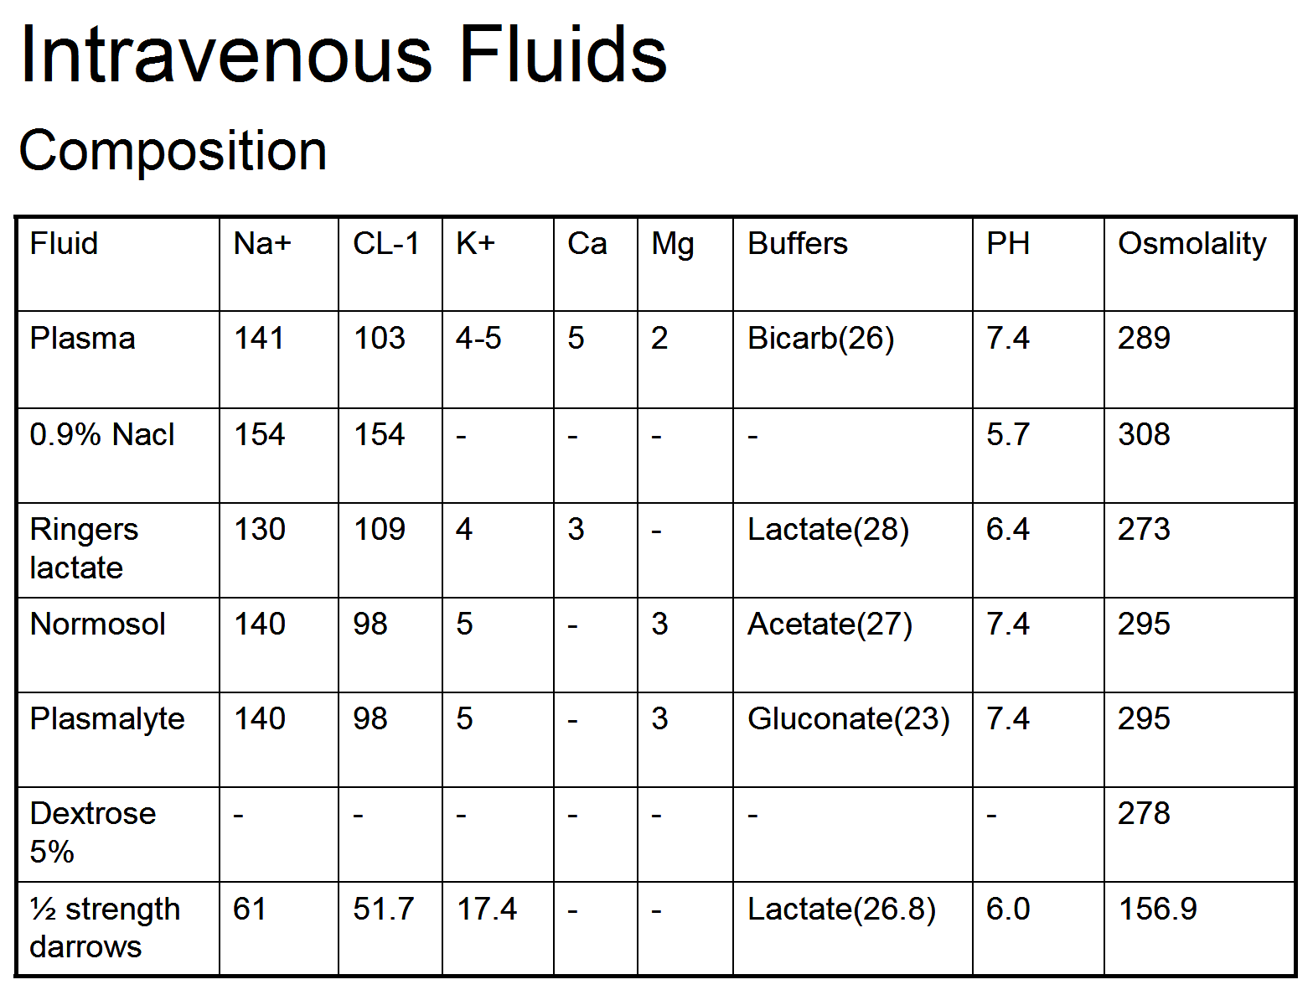

Fluid Management

Consider:

- Pathophysiology of the Disease: What has been lost – water alone, water with electrolytes, plasma, blood (ketoacidosis, diarrhea/vomiting, intestinal obstruction, burns, etc)
- Quantify the amount of loss/deficit (from history, clinical, laboratory, different formulae), weight
- Determine the amount of fluid required in a given time (say – 24 hr)
- Deficit/loss + on going losses + maintenance
- Roughly: Dehydration
- 5% - 50ml/kg + maintenance
- 10% - 100ml/kg + maintenance
- 15% - 150ml/kg + maintenance
- Select the most appropriate fluid(s) for replacement

Phases of fluid replacement

- Resuscitation – 20 – 40min – upto 1 hr to restore intravascular volume:
  - Give upto 40% of half amount to be given in 24 hours
- Repletion phase – 5 – 8 hrs – to replenish ECF (interstitial):
- 60% of half of 24 hr period
- Early recovery phase
- 16 – 24 hrs
- To replenish intracellular volume
- Rest of half of 24 hrs to be given

- Warm Fluids to 37-38C to avoid hypothermia
- Monitor clinical + laboratory data for guidance

Water intoxication management

Treatment

Mild

- Restriction of intake (water)
- Inactivity (several days)

Severe

- Hypertonic saline (1, 8, 3, 5%) to induce diuresis
- ADH antagonists (demeclo cycline ≥ 600mg – nephrogenic diabetes insipitus
- Dialysis (Renal Failure)

Electrolyte Imbalance

Solution of inorganic salts and water

- Positively charged – cations
- Negatively charged – anions
- Their distribution maintains electrical balance of membranes, controls the passage of water through cell walls and maintains acid base balance

Sodium Na+

- The main cation of ECF
- Total body Na+ - 5000 meq(mml)
- ECF – 44%; ICF – 9%; Bones – 47%
- Intake – 80 – 100 meq = 5 – 6g/day
- Excretion – urine, stool, sweat – almost same amount
- The main osmotically active ion in the body

Hyponatriemia (<135 Mmol/l)

May be due to:-

- Gut obstruction (small bowel), rapid loss of gastric, biliary, pancreatic, intestinal secretions (vomiting, aspiration)
- Fistulae – intestinal (high), duodenal, total billiary, pancreatic
- Severe diarrhea (dysentery, cholera, ulcerative colitis, pseudomembranous colitis)
- Inappropriate ADH secretion (OAT cell carcinoma, head injury, etc)
- Irrational administration of water, 5% dextrose, TURP

Treatment

Hypervolemic Hyponatriemia
- Sodium and water restriction
- Diuretics

Hypovolemic hyponatriemia
- Normal saline (not severe)
- Severe
- correct to Na+ 125 meq/l with 3% saline over 6 – 8 hrs
- Correct volume with 0.9% saline
- Correct rest over 72 hrs

Normovolemic hyponatriemia
- Water restriction
- Normal saline + diuretics

Hypernatriemia

From:

- Loss of free water
- Infusion of NaCL post operatively
- Dysfunction of adrenal cortex

Treatment

Hypervolemic Hypernatriemia
- Remove excess Na+ by diuretics, replace free water by 5% Dw
- Dialysis
- Restrict salt

Hypovolemic Hypernatriemia
- Correct volume with 0.45/0.9% saline
- When volume is corrected, replace free water with 5% Dw

Normovolemic Hypernatriemia
- Typically due to diabetes insipidus with normal thirst response
- Treat underlying disease
- Correct free water with 5% Dw
- Restrict salt

Potassium

- Mainly an intracellular electrolyte (>98%)
- About 3500 meq in the body
- ¾ found in skeletal muscles
- Mobilized from muscles when the body is in need
- Normal intake 52-78 meq (2-3g) (fruits, milk, honey)

HYPOKALEMIA

- Serum levels < 3.5 Mmol/l
- May be of sudden or gradual onset
- Sudden: diabetic coma when dextrose + insulin are used, infusion of large amounts of saline, hyperventilation
- Gradual: patients sick for some time

Treatment

- If slow depletion – try conservative management – oral (milk, meat extracts, fruit juices, honey); potassium salts (citrate), Kcl (oral)
- If severe (2.5Mmol/l), Rapid depletion
- IV replacement
- Slowly at <0.5Mmol/kg/hr
- Amount – deficit x BW x 0.3
- Check regularly
- Rule out renal impairment

HYPERKALEMIA

- Serum levels > 5.5 Mmol/l
- Due to:
- Massive tissue injury (crush, burns)
- Acidosis, hypoventilation
- Massive transfussions
- Haemolytic states
- Renal

Treatment

- Remove cause
- Binding – dextrose/insulin
- Blood alkalinisation – NaHCo3
- Ion exchange – Ca++ ions
- Hyperventilation
- Dialysis

CALCIUM

- An extracellular cation
- Concentration – 2.2 – 2.5 Mmol/l
- Exists in forms:-
- Bound to proteins
- Free non ionised
- Free ionised
- Participates in many reactions:- (coagulation, neuromuscular excitability, second messenger, muscular contractility, etc)
- The ionised form falls with rise in PH (e.g. hyperventilation)
- Plasma levels determined by: vitamin D, parathyroid hormone, phyticacid, calcitomine, state of renal and bowel function

Management

Hypocalcaemia

- Identify cause (and treat)
- Vitamin D (when indicated)
- Calcium gluconate – IV/IM
- Calcium chloride
- Oral calcium supplements
- I - hydroxycholecalciferol
- Diet dairy products

Hypercalcaemia

- Has many causes
- 1/3 hyperparathyroidism
- Lithium induced hyperparathyroidism
- Malignancies
- Multiple myeloma, etc
- Parathyroid adenomas

Management

- Remove/treat 1 cause
- Rehydration – 4 – 6l
- Biphosphonates (pamidronate 90mg over 4 hrs)
- Forced diuresis (saline + frusemide)
- Glucocorticoids (prednisone 40mg/d)
- Calcitonin
- Haemodialysis

MAGNESIUM

- Mainly an intracellular ion
- Concentration : 0.7 – 0.9 Mmol/L
- A co-factor in many biochemical reactions

Hypomagnesaemia (<0.7 Mmol/L

May be due to:-

- Excessive use of diuretics
- Administration of insulin in D/ketoacidosis
- Large GIT fluid loses
- Long term parenteral nutrition without supplementation

Treatment

- Oral magnesium hydroxide (poorly absorbed)
- Im magnesium chloride
- Slow IV magnesium sulphate (30-50 Mmol/12 – 24 hrs, then 15 – 20 Mmol/day

Hypermagnesaemia (> 0.9 Mmol/L)

Due to:
- Excessive mgt+ administration
- Renal failure

Treatment

- Remove cause
- IV calcium chloride (emergency)
- Haemodialysis/haemofiltration

